**Question 1**

Deploy a website on localhost using either apache2 or nginx. Create a DNS name for this website as ‘awesomeweb’. You can use any web template you want or can write your own simple html code. Write a detailed documentation with steps involved.

Step 1: Adding the template into the WWW directory under wamp64

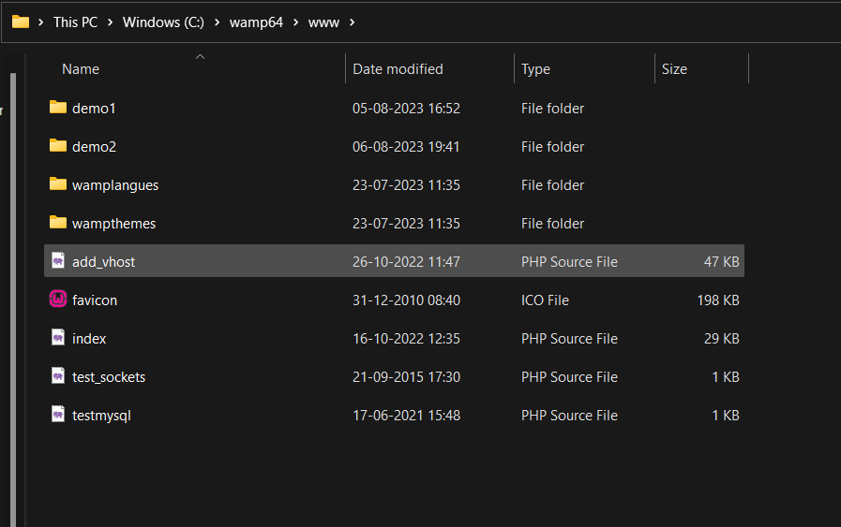

Step 2: Edit the httpd-vhosts conf file to add awesomeweb DNS website

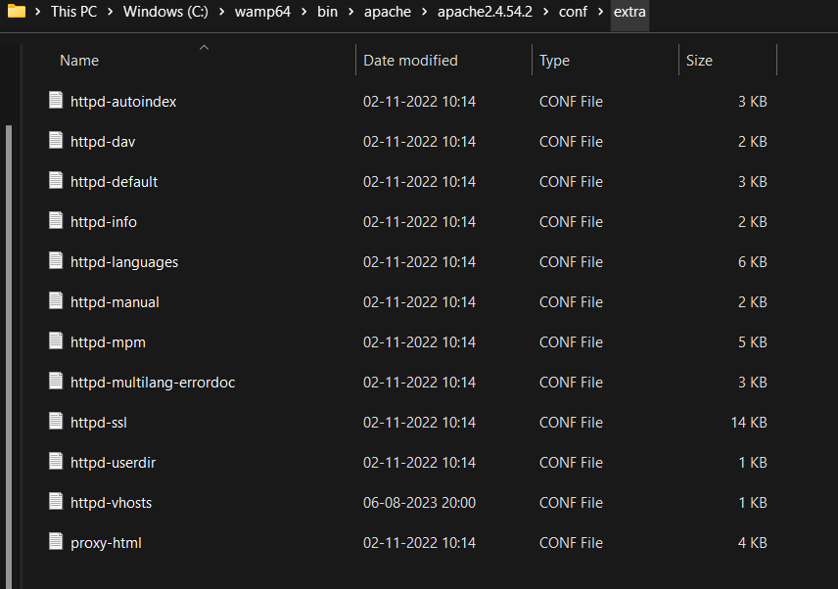

Step 3: server alias is changed to awesomeweb ,so localhost can be awesome web also and demo1 is added in the document root and directory path.

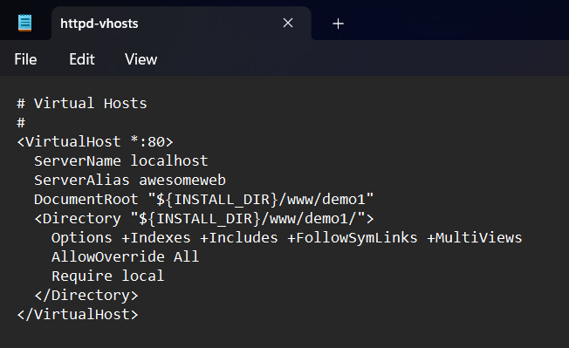

Step 4: open this httpd conf file to check that the file directory is set accurately.

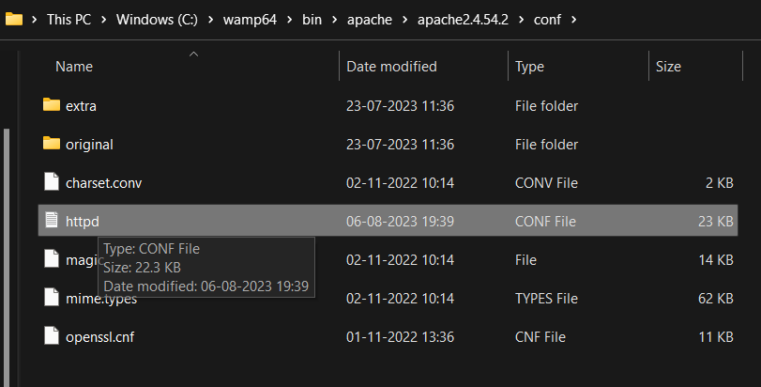

Step 5: now start the wamp

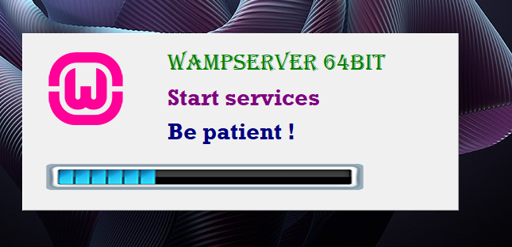

Step 6: search for the localhost/awesomeweb on the browser to view the website hosted locally on apache.

